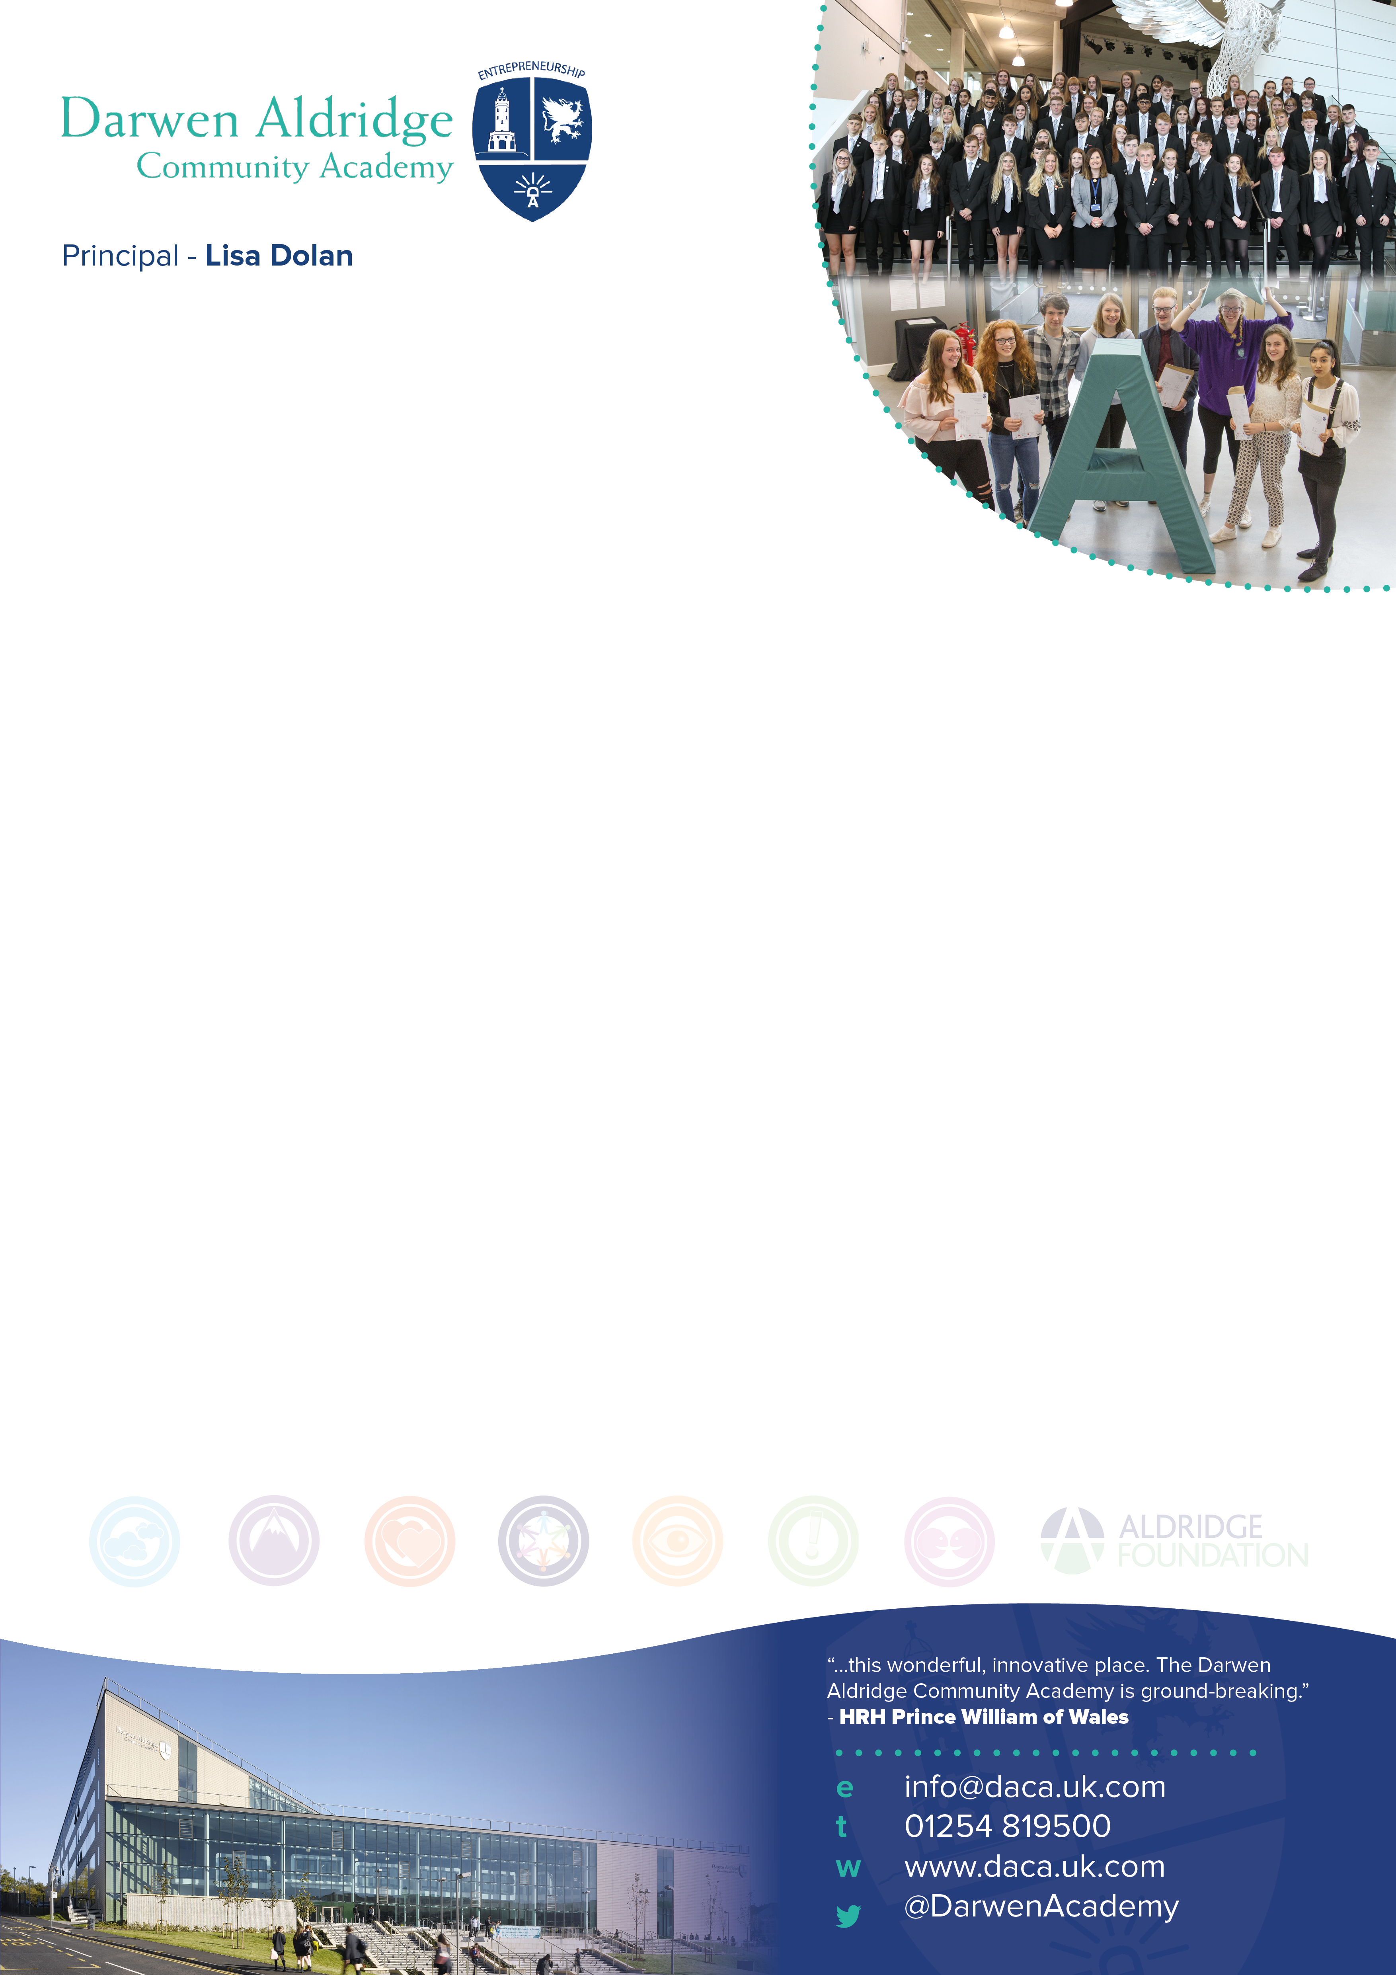

Head of Year 7 (non-teaching and fixed to Year 7)
Permanent, full time, term-time plus 3 weeks
Salary SCP 20-25 – £25,295 - £28,785 FTE
(£23,397 - £26,625 p.a. pro-rata)

We are seeking to appoint a dedicated and ambitious Head of Year 7 to support all students
in their year group and contribute to raising all aspects of achievement, attendance and behaviour.

The successful candidate will also ensure a smooth transition from Year 6, so that students make the very best start to their secondary education. You might be a former teacher (primary or secondary) looking for a pastoral non-teaching role, or an experienced pastoral leader looking for a new challenge.

Darwen Aldridge Community Academy is a larger than average 11-18 academy within Blackburn with Darwen. We are part of Aldridge Education and have 1300 students on role. Our sixth form is in the top 10% of all sixth forms nationally. Our aim is to ‘get better faster’ (Paul Bambrick-Santoyo) and secure an exceptional level of education, which all of our students deserve. Our passion is about realising our students’ full potential regardless of background and coaching our staff at all levels to be able to do this.

We are looking for a committed, enthusiastic leader who will be the first port of call for parents and carers and be highly effective in leading a group of tutors. Someone who:
- can bring together excellent pastoral care and student progress
- is committed to building a culture of excellence and high standards
- is positive, hardworking and creative
- builds teams and is collaborative
- gets things done
- is very capable and is able to lead and inspire with confidence
If this is you and you share our values, we look forward to hearing from you.

We offer:
- coaching, support and line management from an experienced senior leader
- professional progression opportunities and high quality CPD
- an employee assistance programme

Application documents are available to download in the vacancies section of the school website www.daca.uk.com/vacancies Please send your completed application to sam.grimshaw@daca.uk.com by the closing date of 5 p.m. on Monday 6th July Interviews will take place on Friday 10th July.

Head of Year 7
Information for Applicants

June 2020
Dear Candidate
I am delighted that you are interested in becoming Head of Year 7 here at Darwen Aldridge Community Academy. We are a larger than average 11-18 academy, with nearly 1300 students on roll and we are part of the Aldridge Education Trust. Our academy’s passion is realising our students’ full potential regardless of background and our motto is that we all aim to be ‘Determined, Ambitious, Courteous and always Attending’ (DACA). The academy was founded by Sir Rod Aldridge as a way of promoting social mobility and supporting successful communities. We are an inclusive school, behaviour is good and we have high standards and expectations of our students and high standards of care for them.
This new opportunity has arisen due to the promotion of the former post holder. The Head of Year 7 role will be fixed to Year 7 and the post holder will always be Head of Year 7. This is a new role within the team and represents our commitment to giving students an excellent start to secondary school, to developing an expert team to liaise with primary schools throughout the year and to building strong relationships with parents. The aim of the role is to ensure our students achieve well, make great progress and become confident learners because they are supported to do so by a superb Head of Year, who knows them really well.
You will be responsible for the Year 7 group each year and all that encompasses including attendance, behaviour, and progress. The role brings together the academic with the pastoral in order to further improve and help shape the future of our students in the Academy. The successful candidate will be hardworking, creative, collaborative, energetic and passionate about enabling young people to achieve highly through excellent pastoral support. We are looking for someone who is able to both lead and support the Academy in engaging the year group of students to reflect on their learning and the wider role they have in the Academy community, so that they are inspired, confident and ready for their next steps. They successful candidate will have the capacity to help us to further develop the learning environment, break down barriers for learning and build a culture of excellence and enthusiasm for learning. Their professionalism and dedication will enable our students to achieve more than they believe possible.
The pastoral team is led by the Vice Principal and compromises of 2 Assistant Principals, KS3 and 4 behaviour leads, 4 pastoral managers for years 8-11, a student services team, an Education Welfare officer, target support leads, 2 school counsellors and a HLTA dedicated to LAC and PP students. The team works collaboratively in a centrally located pastoral office.
You would work on a day to day basis with the Assistant Principal Transition and Inclusion, The Assistant Principal Standards and Student Leadership, The Vice Principal Pastoral Care, the wider pastoral and inclusion team and Senior Leadership. The post is permanent and 37 hours per week, term time plus 3 weeks (Including Professional Learning Days) Experience of working in schools or a related professional service is essential.
Our academy and Trust are committed to the power of coaching and how we ‘get better faster’ using the methodology of Paul Bambrick-Santoyo. We believe that we are all learners, and we realise that all staff need a coach regardless of level and experience. We believe that everyone is able and ready to inspire others with their subject scholarship, expertise in their area and passion for their role.
Whilst we are currently graded as a good provider by Ofsted, have achievement at KS5 in the top 10% of all schools nationally, we do not rest on our laurels and we are always striving to improve.
Should you have any queries about the role or wish to have a confidential discussion with me, then do contact my PA sam.grimshaw@daca.uk.com who will arrange a call. I realise these are unusual times and that the normal school visits aren’t necessarily possible but I am more than happy to talk and answer any questions.

To comply with social distancing our interview process will take place mainly via online video conferencing. Shortlisted candidates will have an initial fact checking video call. This will be followed by video interviews, each of which will focus on a different aspect of the role. As we will not have an opportunity to observe you lead and interact fully with students in school, we will seek evidence of this and other key aspects of this role from you and your referees.
Please find enclosed with this letter;
- A job description for the post
- A person specification for the post
- An application form

I hope that this information will encourage you to apply for this key post. Please return completed application form, along with a supporting letter of no more than two sides of A4, before the closing date of 5.p.m. on Monday 6th July. Applications should be submitted electronically to my PA, Sam Grimshaw (sam.grimshaw@daca.uk.com).

As interviews will mainly be through video calls, initial calls will take place on Thursday 9th and interviews on Friday 10th
July.

I look forward to receiving your application.

Yours sincerely
Lisa Dolan
Principal

The Academy is committed to safeguarding and promoting the welfare of children and young people. References will be taken up for all shortlisted applicants, and successful candidates will be subject to satisfactory enhanced disclosure from the Disclosure and Barring Service. If you do apply for the above position and have not heard anything within one week of the closing date, you can assume that you have not been short-listed on this occasion.

JOB DESCRIPTION

Job Title: Head of Year 7

Salary:
SCP 20-25 – £25,295-28,785 FTE (£23,397- £26,625 p.a. pro-rata)
Responsible to:
Assistant Principal Transition and Inclusion and through them to the Vice Principal (Pastoral Care). The post-holder will also work closely with other members of the Pastoral Team.
Responsible for:
Students within Year 7
Working Pattern:
Hours are 37 hours per week
(Term time + 3 weeks including all Professional Learning Days)
Key Relationships:
Academy Leadership Team; allocated students, teaching and support staff; Academy Trust staff and governing body; LA representatives; Academy community including parents/carers, external agencies, local community and other schools
The Purpose of the Job

To work under the guidance of the Assistant Principal for Transition and Inclusion and Vice Principal behaviour welfare and to maintain a strong team ethos within the pastoral team.

To ensure student welfare and effective behaviour management of Year 7, of around 240 students with a view to remaining with the cohort.

This role will ensure that barriers to learning are removed for all students using an inclusive ethos where a smooth transition is made from primary, to secondary education.

To provide direction to students through setting challenging and demanding expectations for students and promoting their self-esteem and independence.

General

There is an expectation that the post-holder will support and contribute to the development of the overall, aims and values ethos of the Academy, and will work towards the Academy’s aims as expressed in the Academy Improvement Plan and other relevant documentation.

Key responsibilities
Monitor the attendance and punctuality of all students within the Year 7 group and provide accurate and timely reports on this for parents (including first day contact), the Vice Principal and the Academy Leadership Team.
Provide feedback to students in relation to attainment, progress, achievement, behaviour, and attendance and liaise with individual teachers and faculties in relation to the monitoring of individual student behaviour and progress.
Initiate and maintain contact with parents or carers of students with attendance difficulties, including the organisation of home visits where appropriate. Identify circumstances where attendance is affected by social personal or emotional difficulties and taking appropriate action including referrals to the appropriate agencies.
Be committed to safeguarding and work closely with the safeguarding team to ensure any concerns are acted on in a timely and effective manner. This includes leading on CAFs, attending core group meetings, attending CP conferences and preparing reports on children as may be required by social workers, courts or any other external agencies.
Make and manage referrals, as appropriate, to external agencies and lead on this contact. This includes leading on meetings involving external agencies and reviewing the support that has been offered and the subsequent impact.
Be an exemplary leader and ensure good communication with parents, members of academy staff, external agencies and other education providers by use of personal contact, letters, telephone calls, emails and other means as appropriate.
Contribute to the school behaviour policy and consequences system by being visible around the Academy at key lesson changeovers, supporting the ‘on call’ system and being part of the rota, working with Directors of Learning to ensure a culture of excellence is visible in all faculty areas and identify students with persistent behavioural issues, putting individual plans in place in liaison with the pastoral team, SENCo and external agencies, as appropriate.
Manage students immediately before and after the academy day and at break at lunchtimes.
Contribute to the school rewards policy and lead on and assist with rewards events in collaboration with key staff.
To provide strategic leadership for the academy anti-bullying and restorative justice policies and procedures and practice. This includes interviewing students and taking appropriate action following referrals related to school work, behaviour, bullying and racist incidents and any other student concerns or crisis.
Be responsible for creating, keeping and updating records containing privileged and highly confidential information for vulnerable student groups including relevant fling, as agreed with other staff, contributing to reviews of systems/records as requested.
Lead and manage the pastoral care and guidance of students including CIOC, those with EHC plans, IPRAs and vulnerable students with collaboration from the LAC lead and the SENCo. Develop and implement individual education, behaviour and progress plans and provide tutoring and personal care programmes as required. This may also include carrying out home visits, where necessary, for students or parents in need of pastoral support.
Provide feedback to students in relation to attainment, progress, achievement, behaviour, and attendance and liaise with individual teachers and faculties in relation to the monitoring of individual student behaviour and progress.
Liaise with individual teachers and faculties in relation to the monitoring of individual student behaviour and progress. This includes participating in comprehensive assessments of students’ academic and pastoral progress.

Liaise with and visit all feeder primaries to ensure effective transition for all year 6 students, ensuring that students with SEN and other vulnerable groups have their needs met and to ensure effective and high quality transition.
Be responsible for creating, keeping and updating records containing privileged and highly confidential information for vulnerable student groups including relevant fling, as agreed with other staff, contributing to reviews of systems/records as requested.
To manage mid-term admissions and transfers including the sharing of information within DACA and other external agencies.
Support the organisation of Parents’ Evening/Open Evenings and other calendared events.
Organise collect and provide the delivery of work for students educated off site due to illness or placement.
Contribute to the tutor time programme through leading pastoral meetings and through daily drop ins to tutor to ensure the programme is being followed and that students are engaging and following Academy expectations. This also includes supporting new staff and NQTs during form time to help set the standards and expectations.
Assist with and lead Year & Assemblies as directed by Assistant Principal Standards and Student Leadership.
Plan and implement reward events in collaboration with appropriate staff.
Cover lessons and tutor sessions due to unforeseen circumstances if necessary.
Organise and manage Year 7 extra-curricular, charity and community activity.
Additional duties
Attend team meetings and staff meetings as required.
Maintain confidentiality inside and outside the workplace.
Take responsibility for promoting and safeguarding the welfare of students with whom the post holder comes into contact.
Comply with policies and procedures relating to child protection, equal opportunities, health and safety, confidentiality and data protection, freedom of information and report all concerns to the appropriate person.
Develop constructive relationships and liaison between managers/teaching staff and support staff.
Develop positive relationships and communicate with other agencies/ professionals.
Work flexibly to promote extra-curricular activities and out of hours learning which enhances learning opportunities.
Engage in relevant and challenging continuous professional development opportunities.

To undertake other duties as may reasonably be assigned by the Principal or the Academy Trust, recognising that the duties of this post may vary from time to time without changing the general character of the post or level of responsibility. Recognise that roles and responsibilities may change as the Academy develops
The post holder will be expected to operate in line with Aldridge Education operating norms which are:
- We are Aldridge
- The standard is excellence
- Our people matter
- We’re in the work together
- Character is key
- We lead by example
- Every moment matters
Other

To undertake any other appropriate duties as required by line management or senior staff.

Training

The post holder will be expected to undertake professional development as appropriate to the post and in the context of personal development.

Other Requirements

From time to time, the post holder may be required to vary their working hours to fit in with the Academy calendar. This will be directed by the Principal. Advance notice will be provided.

PERSON SPECIFICATION

JOB TITLE: HEAD OF YEAR 7

 | Essential | Desirable | Evidence
Knowledge,  skills and abilities | - Extensive experience of working effectively in the support of young people in a learning environment  - Good understanding of the principles of child development and learning processes and in particular barriers to learning  - Evidence of having developed sustained and effective relationships with young people in a pastoral context  - Evidence of implementing excellent behaviour management strategies leading to the development of positive attitudes in young people particularly towards education and learning  - Effective use of ICT and technology  - A strong understanding and commitment to the Academy’s ethos and approach to student learning and achievement  - Evidence of ability to contribute to safeguarding and protecting the welfare of children  - Evidence of the ability to successfully motivate young people  - The ability to communicate effectively to different audiences both orally and in writing including the ability to promote the image of the Academy  - Experience of working effectively with a range of internal and external stakeholders including parents and carers  - Experience of working in a highly confidential environment  - Experience of working effectively within a team and of leading and managing others  - Exceptional organisational and prioritisation skills  - Able to challenge without confrontation | - The ability to empathise with young people  - Modelling of de-escalation techniques  - Experience of using CPOMS  - Experience of using SIMS | Application form  Interview
Education, training and qualifications | - Educated to at least Level 3 (A level, BTEC) standard, including GCSE grade C in maths & English  - Current first aid certificate (or willingness to be trained in first aid)  - Evidence of relevant and challenging continuing professional development  - Experience of working with young people, preferably in an education environment | - Higher Education at degree level  - CAF Practitioners Training  - CWDC Training - Level 3/4  - Think Family Relationships and Sexual Health Training  - Self-Harm - Training  - LSCB Introduction to Safeguarding Level 1  - Child Exploitation Training  - Bereavement Training | Application form
Personal Qualities | - Commitment to high educational, professional and personal standards  - High professional standards of appearance and dress  - Commitment to the ethos of Darwen Aldridge Community Academy and Aldridge Education Operating norms  - A flexible and calm approach to work including a sense of humour, positive outlook and willingness to consider and bring new ideas  - Obvious enthusiasm and energy  - Ability to stay calm and work effectively under pressure  - A willingness to be involved in the wider activities of the Academy  - Ability to demonstrate, understand and apply our values and operating norms:  - We are Aldridge  - The standard is excellence  - Our people matter  - We’re in the work together  - Character is key  - We lead by example  - Every moment matters |  | Application form

