French GCSE

1. **Exam dates**

Paper 1 – Listening 12.05.2020 (AM)

Paper 2 – Reading 12.05.2020 (AM)

Paper 3 – Speaking Week beginning 27.04.2020

Paper 4 – Writing 15.05. 2010 (AM)

1. **Exams content**

Students are entered for either Foundation Tier (top grade 5) or Higher Tier (top grade 9)

**Paper 1: Listening Exam**

25% of the marks

Foundation Tier: 40 marks; 35 minutes (including 5 minutes' reading time)

Higher Tier: 50 marks; 45 minutes (including 5 minutes' reading time)

**Paper 2: Speaking Exam**

25% of the marks

Foundation Tier: 60 marks; students will attend one session of 7–9 minutes (and supervised preparation time of 12 minutes).

Higher Tier: 60 marks; students will attend one session of 10–12 minutes (and supervised preparation time of 12 minutes).

Content of speaking exam:

Students practice the 3 tasks of the speaking exam throughout the course and develop their understanding

of what is expected of them.

1) Role-Play:

5 bullets points, 2 marks each + 5 marks for Knowledge of Language

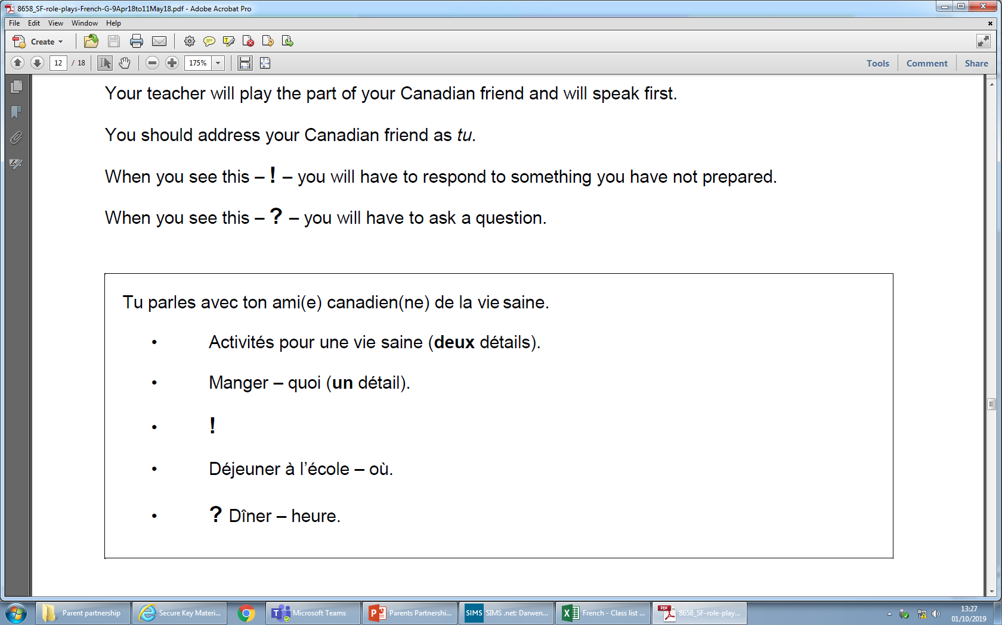Activity is simple as long as vocabulary is known.

Example:

Activities for a healthy lifestyle (2 details)

*I eat some vegetables and I drink water.*

Je mange des legumes et je bois de l’eau. (full mark)

Eat – what (one detail)

*I eat some chicken.*

Je mange du poulet. (full mark)

2) Photocard:

3 questions that students prepare during their preparation time + 2 questions unprepared.

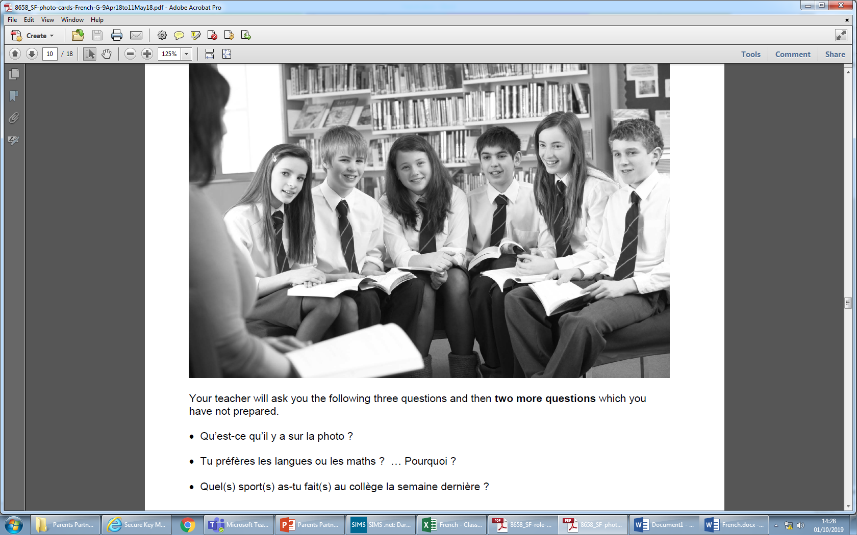

The first question is purely descriptive: “Qu’est-ce qu’il y a sur la photo?” (What is on the photo?)

Example: *There are 6 students and one teacher. They are in the library. They listen to the teacher.*

“Il y a six élèves et un prof. ils sont dans la bibliothèque. Ils écoutent le prof.

The second and third questions are more personal and one opinion + justification should be expressed.

Success criteria for full mark (15 marks):

- 3 short sentences/statements for questions 1, 2 and 3

- One opinion with justification of opinion

- Unprepared questions 4 and 5: short response in enough (1 sentence)

3) General conversation.

Students have a general conversation booklet and it is completed throughout the course.

**Paper 3: Reading exam**

25% of the marks

Foundation Tier: 60 marks; 45 minutes

Higher Tier: 60 marks; 1 hour

**Paper 4: Writing exam**

25% of the marks

**Foundation Tier: 50 marks; 1 hour**

Task 1 – Photo description

Candidates are expected to write 4 short sentences (2 marks per sentence; max mark 8)

Example:

There are 6 people.

*Il y a six personnes.* (2 marks)

They are in a park.

*Ils sont dans un parc.* (2 marks)

A man/a boy / a person cycles.

*Un garcon fait du vélo.* (2 marks)

The weather is nice.

*Il fait beau.* (2 marks)

Task 2 – 40 words in French

“You write a blog about your school.

Mention:

- subjects

- teachers

- buildings

- meals”

Example in Engllish:

I study English, maths, science, history and PE. I like science because it is interesting. The teachers are kind but the maths’ teacher is strict.

The buildings are modern and big.

I eat in the canteen and it is nice.

40 words – full mark 16/16

Vous écrivez un blog sur votre collège.

Mentionnez:

• les matières

• les professeurs

• les bâtiments

• les repas.

Ecrivez environ **40** mots en **français.**

Success criteria:

- All bullet points covered

- knowing vocabulary

- Ability to write simple sentences

- Mistakes are accepted. It only needs to be generally accurate to get full mark.

Task 3 – translation

Example: (2018 exam paper)

I live in a small village.

Task 4: 90 words in French (full mark /16)

Success criteria:

* The task is made of 4 bullet points and the 4 bullet points need to be covered. No need for equal coverage between bullet points.
* Approximately 90 words to communicate a lot of information.
* Communication is clear or mostly clear.
* Some complex structures.
* A variety of vocabulary.
* 3 tenses: past, present and future.

**Higher Tier: 60 marks; 1 hour 15 minutes**

Task 1: 90 words in French (full mark /16)

Candidates have a choice between 2 tasks.

Success criteria:

* The task is made of 4 bullet points and the 4 bullet points need to be covered. No need for equal coverage between bullet points.
* Approximately 90 words to communicate a lot of information.
* Communication is clear or mostly clear.
* Some complex structures.
* At least 2 opinions.
* A variety of vocabulary.
* 3 tenses: past, present and future.

Task 2: 150 words in French (full mark /32)

Candidates have a choice between 2 tasks.

Success criteria:

* The task is made of 2 bullet points and the 2 bullet points must be covered.
* Approximately 150 words to communicate a lot of information.
* Communication is clear.
* Some complex structures.
* At least 2 opinions which are justified.
* A variety of vocabulary.
* 3 tenses: past, present and future.

1. **Revisions**

- Vocabulary list

- Speaking booklet

- Revision guide

- <https://www.bbc.co.uk/bitesize/subjects/z9dqxnb>

- <https://www.samlearning.com/>

- <http://www.gojimo.com/gcse-french-revision>

- <https://app.senecalearning.com/classroom/course/a2a73a1c-891a-40e3-9c38-1aafb04acfa8>

French AQA GCSE

- [www.quizlet.com](http://www.quizlet.com)