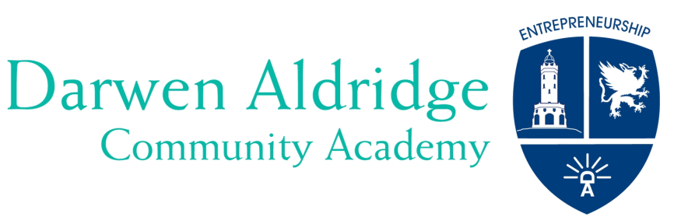

Darwen Aldridge Community Academy & Sixth Form
Sudell Road, Darwen, Lancashire BB3 3HD
Tel: 01254 819500 Fax: 01254 819501
Student Services: 01254 819540
www.daca.uk.com
email: info@daca.uk.com

‘Realise your potential’

Dear parent/carer
I hope you are your families are well during these turbulent times.
I wanted to write to you to summarise and clarify what the government has said this week and to update you on any school news.
None of us wanted to be in lockdown again but we will continue to work hard at Darwen Academy to educate our students and to support our community and parents.
We have moved to remote learning and we are open to students who are vulnerable or whose parents are key workers. Our remote learning policy is on our website and we would like to remind you that we are following our usual timetable. All details can be found in the learning section of our website and each year group has a dedicated page.
We will continue to praise our students via postcards and subjects will also do this on twitter. Our plan is to also hold assemblies and continue to provide some of the normal things, which are part of school life.
Thank you if you attended the Year 11 parents’ evening last night. This was our first online parents’ evening and we will continue to use this throughout the year for other Year groups. Feedback appears to have been very positive from parents and thank you for your positive comments about our remote learning provision.
Remote learning
We are working hard to provide laptops to families who need them. Please do not hesitate to contact us for support with any IT issues servicedesk@daca.uk.com
Full ‘how to’ guides are also available on our website in the Year group web pages.
The government expects every school to have a digital education platform, to provide between 4/5 hours of teaching per day for students in key stage 3, 4 and 5 and for some of this to be via video lessons (either school-led or using other providers like Oak National Academy)
Our digital platform is Microsoft Teams and teachers will use this as the main platform, upload work there, deliver a combination of live lessons and pre-recorded content, as well assess and give feedback to students via Teams and any other subject specific platforms. Students will also be able to upload completed work for their teachers to assess.
We are monitoring students’ attendance and engagement in remote learning and our pastoral teams will be calling parents to find out how we can work with you if students are not engaging in learning.
Our art department will be sending out resources in the post to families for KS3, 4 and 5.
Year 11 1 to 1 careers interviews will go ahead remotely and interview times have been organised.
Assessment
GCSEs, AS and A Levels won't go ahead this summer. Ofqual will consult on alternative arrangements. The DfE expects that these "will be based on teacher assessment". I will update you as soon as I have more information. In the meantime, it is essential that students in exam years i.e. Year 10, 11, 12 and 13 complete all tasks, tests and assessments set by teachers, as these along with mocks grades will enable us to provide evidence for any future teacher assessment.
We decided to go ahead with BTEC exams this week as our students were prepared for them.
Free school meals
From next week we will be providing Free School Meal vouchers via ‘Wonde’, which is the same method we used during the first lockdown. We will contact you to ensure that your mobile number is accurate and up to date as this is important for the delivery of the voucher.
COVID -19 Testing
This week we have begun rapid testing of any staff and students on site. Thank you if you have returned your permission form. Students and staff will be able to access daily testing if they're a close contact of a confirmed coronavirus case, and staff will have access to weekly testing.
Support for parents and carers
Mrs Lewis will shortly be contacting you with information on a workshop on how to support your child’s mental health and motivation.
We will also be arranging a parent and child workshop on 10th February at 6 p.m. for Year 10. This will provide parents with skills and resources to help their child prepare for GCSEs. Mrs Lewis will provide more details about this next week.
New phone system
We have a new phone system in operation. This gives callers a menu of options from which to choose. Our reception is open and manned daily from 8:30 a.m. until 3:30 p.m.
I would like to thank you for your continued support and good wishes. Please get in touch with us via the usual channels if you need advice or support. We will send messages via Edulink if we need to communicate with you and to give advice, information or support.

Yours sincerely
Mrs L Dolan

